**Project Design Phase-||**

**Technology Stack (Architecture &stack)**

|  |  |
| --- | --- |
| **Date** | **02/11/2023** |
| **Team Id** | **NM2023TMID22194** |
| **Project Name** | **How to create a landing page on hubspot** |

**Technical Architecture:**

The Deliverable shall include the architectural diagram as below and the information as per the table1 & table 2.

**Example:**

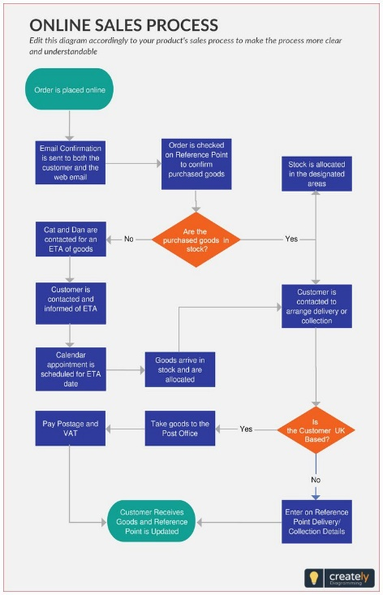

|  |  |  |
| --- | --- | --- |
| **Sno :** | **Description** | **Technology** |
| **1.** | User Interface | HTML, CSS, JavaScript and Hubspot Page builder. |

**Table-2 Application characterstics:**

|  |  |  |  |
| --- | --- | --- | --- |
| **S.No** | **Characteristics** | **Description** | **Technology** |
| **1.** | Open-Source Frameworks | List the open-source frameworks used | Technology of Opensource framework |
| **2.** | Security Implementations | List all the security / access controls implemented, use of firewalls etc. | e.g. OAuth |
| **3.** | Scalable Architecture | Justify the scalability of architecture (3 – tier, Micro-services) | Technology used |
| **4.** | Availability | Justify the availability of application (e.g. use of load balancers, distributed servers etc.) | Technology used |